# Introduction

This Linux lab is designed to help you practice and develop your skills in using Linux commands and performing basic system administration tasks. The lab is divided into five sections, each with specific objectives to achieve.

# Objective

* Practice creating and sorting files, and taking screenshots.
* Develop skills in locating and manipulating files, creating new users, and copying files between users.
* Improve knowledge in user privilege management, process identification, and binary file location and analysis.
* Practice file manipulation and compression techniques and develop knowledge of file space optimization.
* Develop scripting skills by creating a shell script that performs a specific task and taking a screenshot to demonstrate proficiency.

# Instructions

* Use a Linux virtual machine to complete all the objectives for this lab
* Follow the instructions in each section and take screenshots displaying the items you have been requested to do.
* Create a new Google Docs file and title it with the name of the lab.
* Organize your screenshots by section and upload them to the Google Docs file.
* Write a reflection on the skills you have used for this lab.
* Upload the Google Docs file on the designated date.

# Section A

1. Create a file with the first and last names of all your classmates

2. Sort the file alphabetically

3. Take a screenshot of this file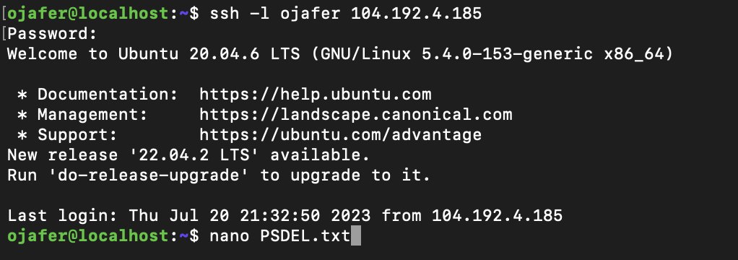

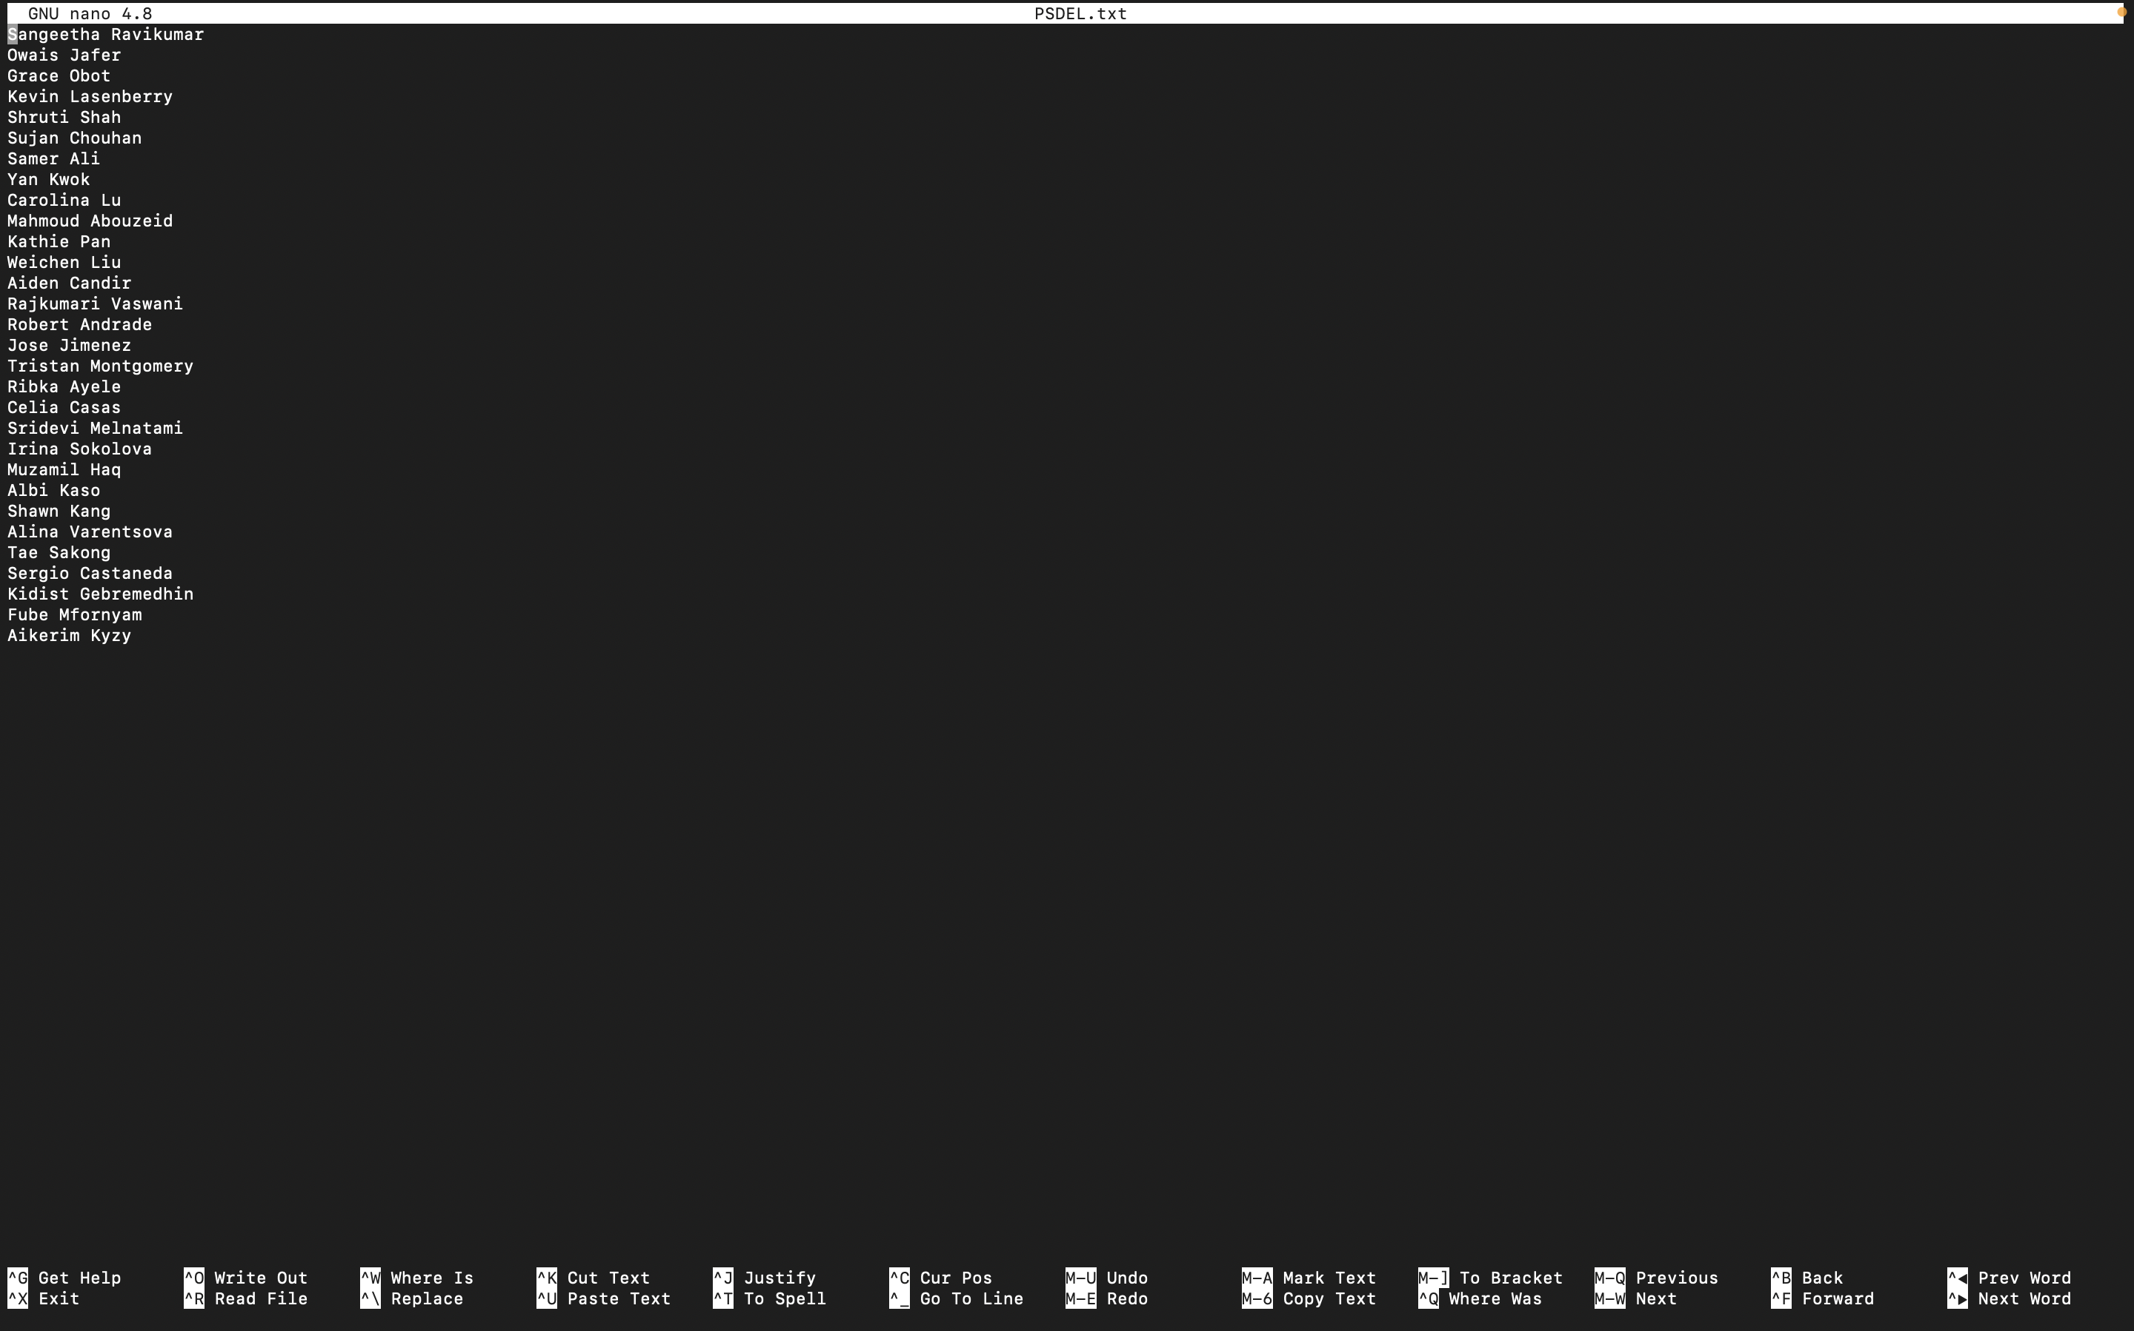

# 

# Section B

4. Use the command find ~~or locate~~ to identify the location(s) of the file “login.defs” on your ubuntu system.

5. What command would you use to see the last 10 lines of the /etc/login.defs file

6. Save all the entries with the word “If” in the /etc/login.defs file to a new fi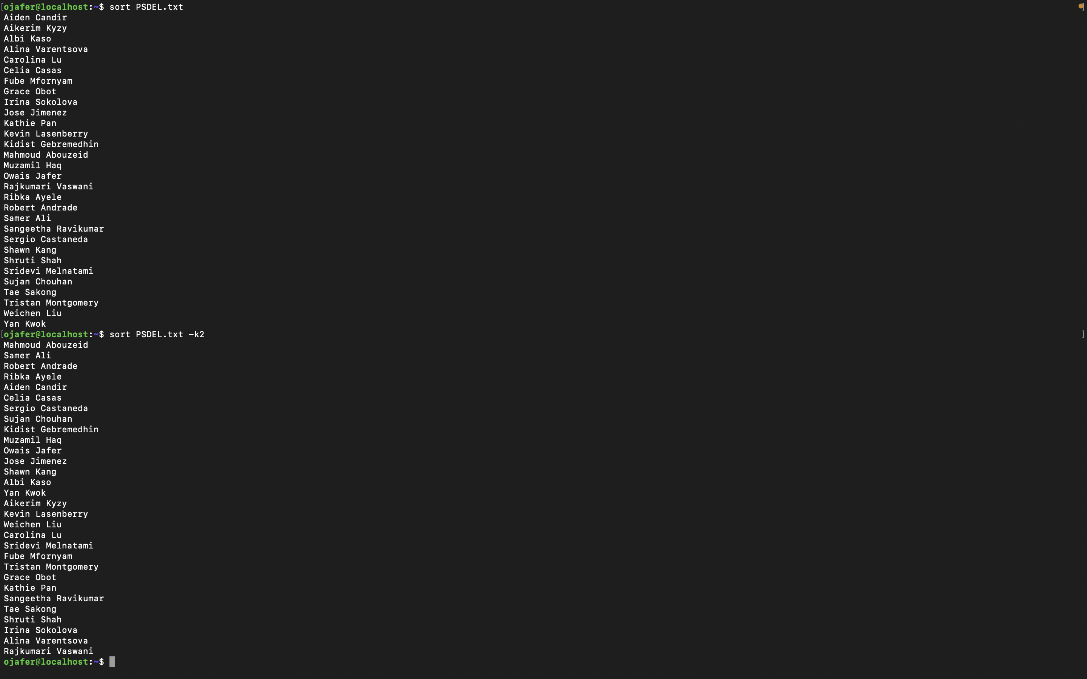le called If.txt in your home directory.

~~7. Create a new user called test. Use su to login as test~~

~~8. Copy the error.txt file from your user directory into the test user's home directory~~

~~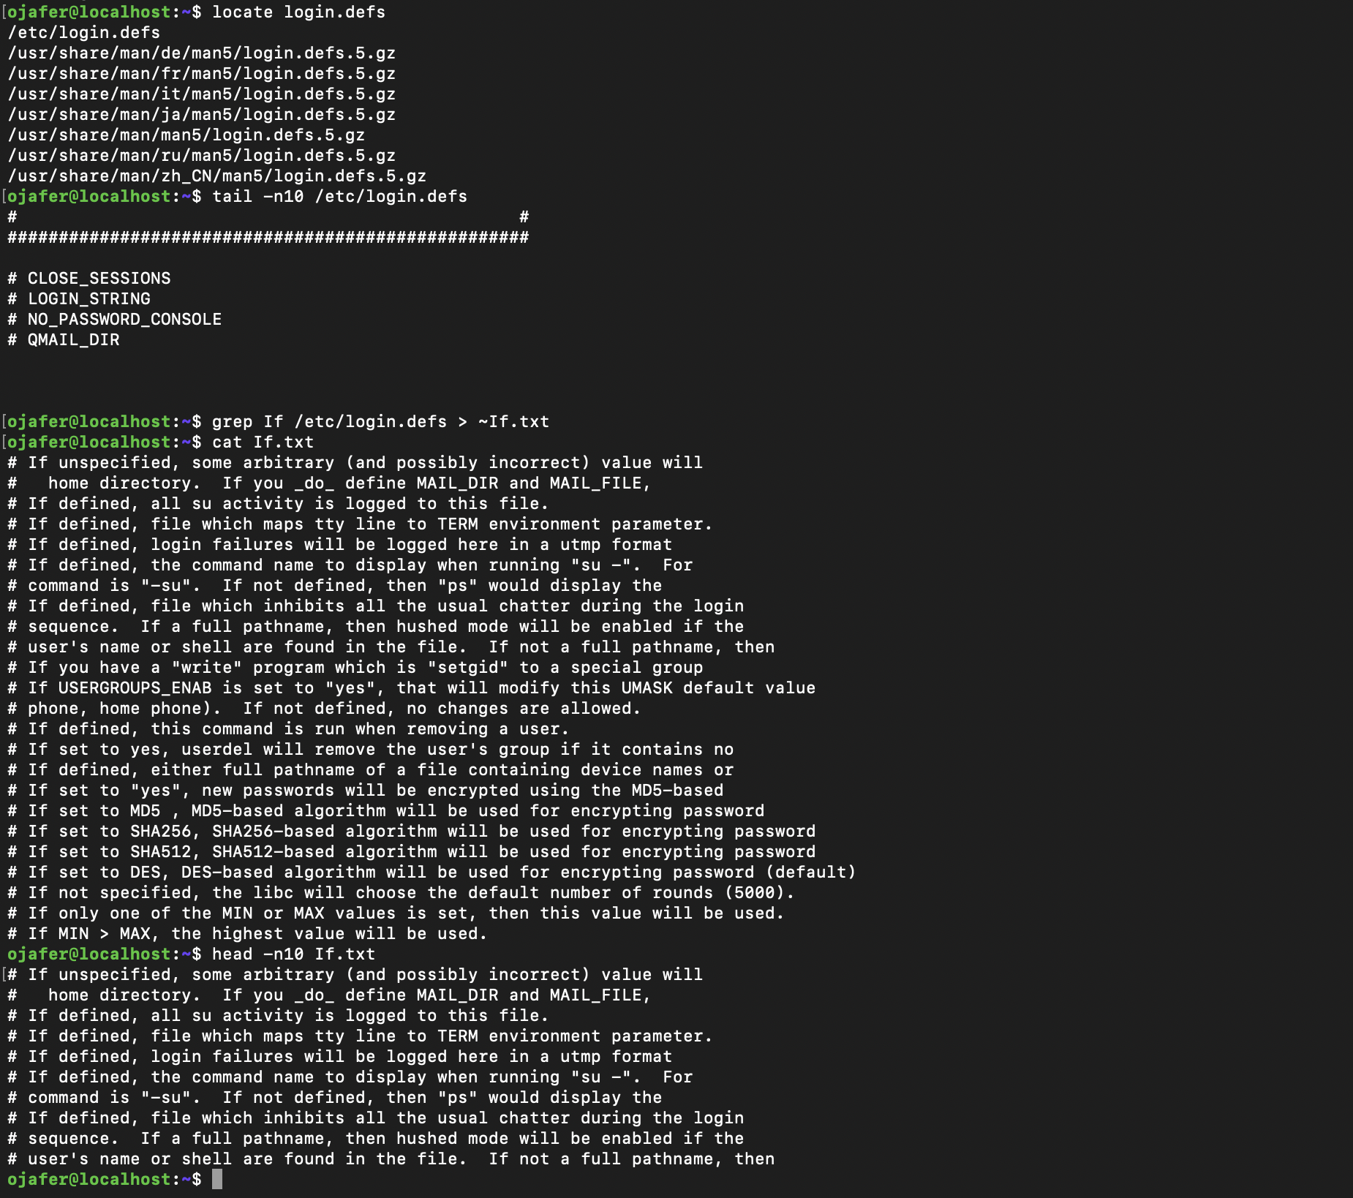~~

9. Take a screenshot which displays the first 10 lines of your new file If.txt.

# Section C

~~10. Elevate your user privilege to be the root/superuser on this system.~~

11. Check which process is consuming the max ~~memory~~ CPU resources on your ubuntu system : Process with PID 805 uses the max CPU resources

12. Does this process have a parent process? : Yes, the parent process for PID = 805 is a process with PID = 798

13. Where is the binary file for this process located and what is the size and permissions on this file : /bin/bash ./mvs

14. Take a Screenshot to display information on this file.

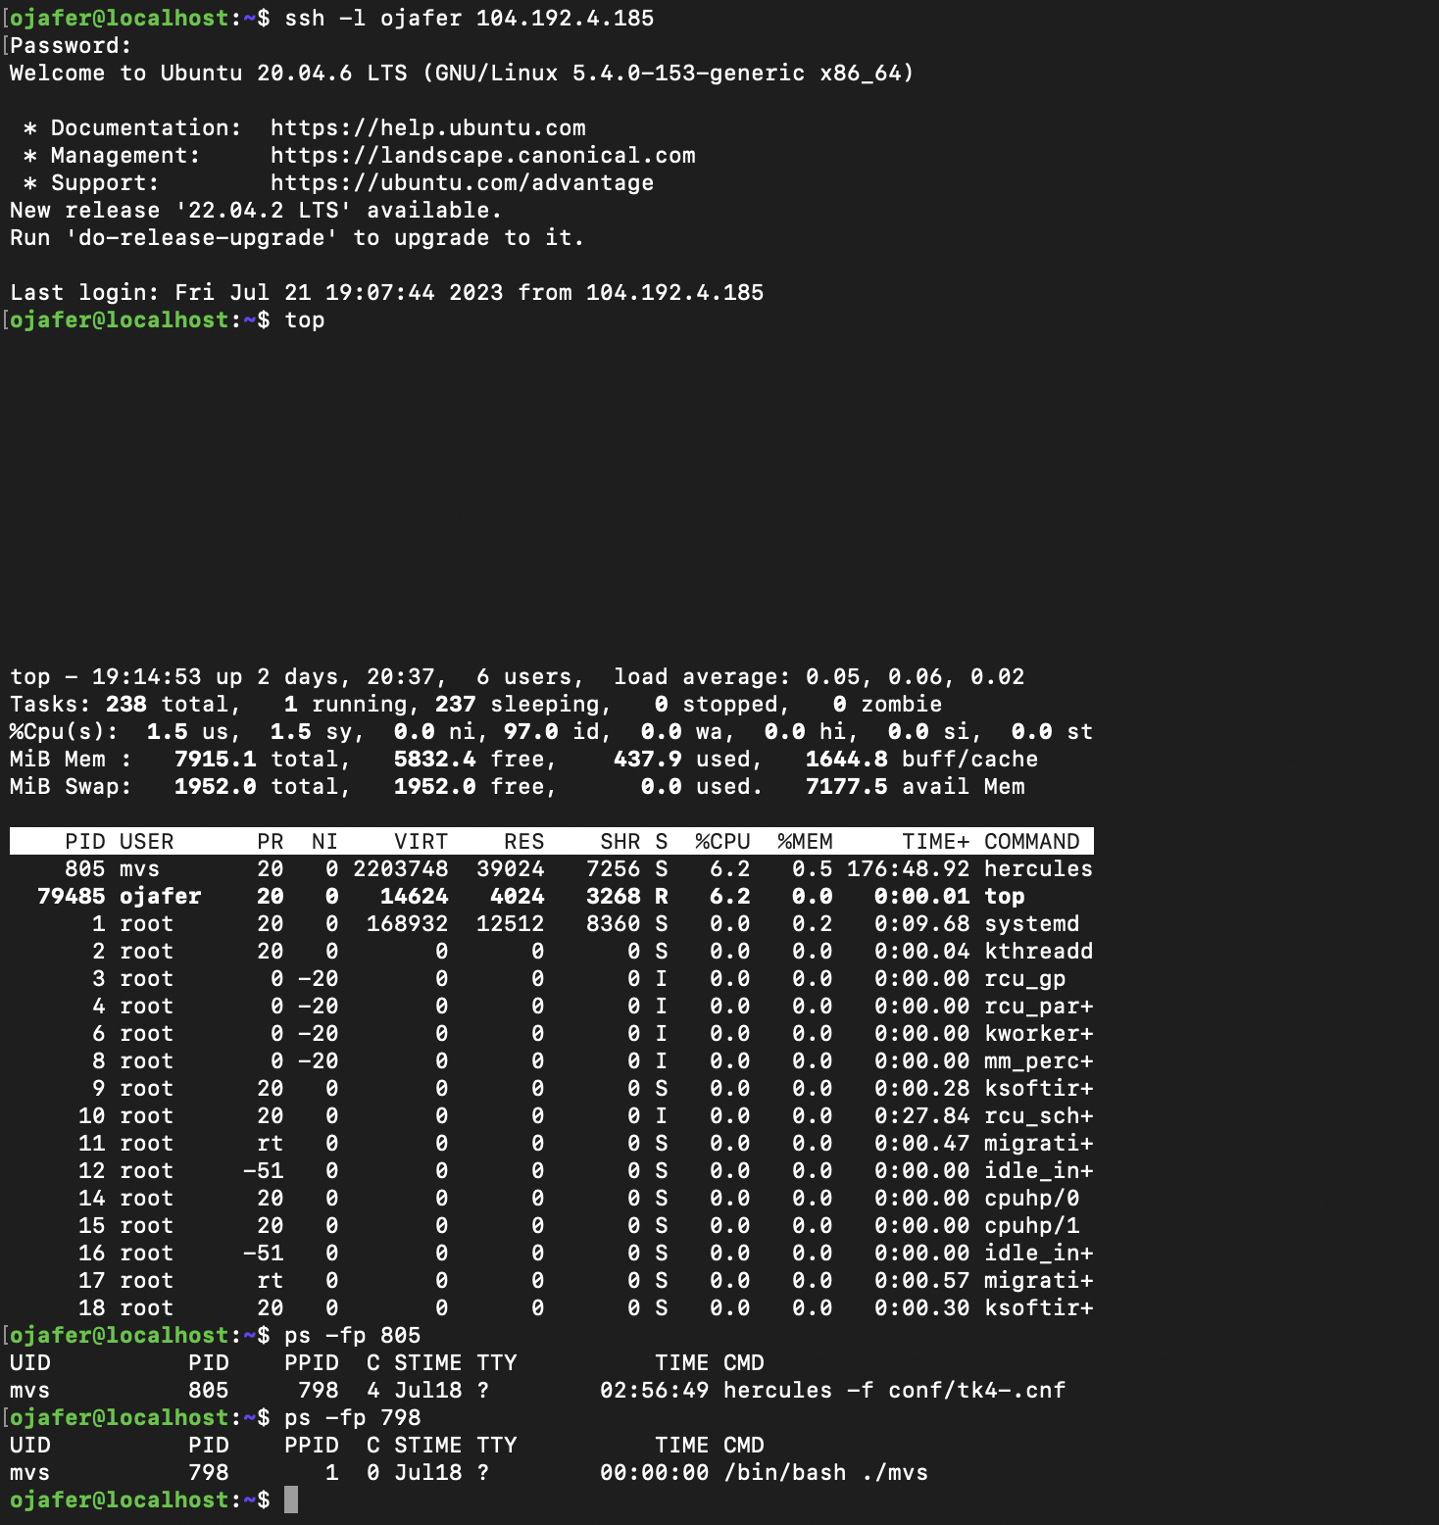

# Section E

22. Create a sample shell script that prints out every odd number between 0-100.

23. Submit Screenshot as evidence.

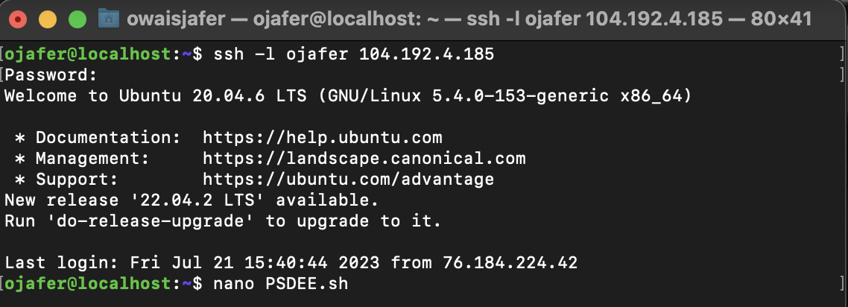

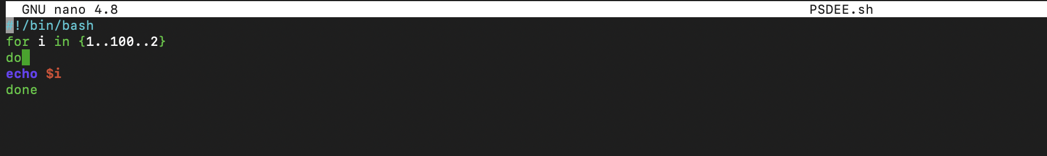

# E-3.png

# Reflection

What have you learned about the skills you used for this lab?

I learnt how to move files between directories, create functions using bash script, and create editable files using Nano. I also learnt how to see the data existing within files.